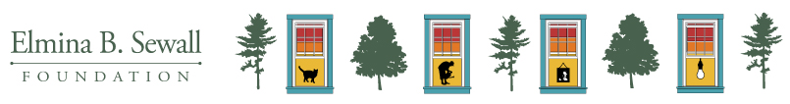

Progress Report

At the Sewall Foundation, we view grant reporting as an opportunity for us to get to know you and your work more deeply and to gain insight into ways we can be a better partner to our grantees. This information helps us better understand the communities we serve. We ask the questions below in the spirit of curiosity, partnership, and commitment to learning with and from you.

We are committed to only asking for information that we can review and use to inform our work. For this reporting form, there are no word limits, just an invitation to share what you believe is most important for us to know. In general, one paragraph is recommended for each response. Please feel free to copy and paste responses created for other funders. If we need more information or have questions, we will reach out.

Please email completed reports to Lisa Smith at lsmith@sewallfoundation.org.

Organization Name:
Grant Contact Name:
Grant Contact Email Address:

Accomplishments
Please share something you’re really proud of that your organization has done in the past year.

Learning
What are the big issues or strategic questions your organization, collaborative, or field is grappling with?

Support
Did the funding (and other support) from Sewall affect your organizational health over the past year (Catchafire, convening, etc.)? If so, in what ways (positive or negative)?

Additional Thoughts
Is there anything more we could be doing to support your work or our relationship with you?

