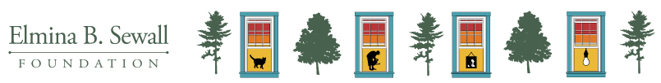

Progress Report for Grants Requiring Expenditure Responsibility

At the Sewall Foundation, we view grant reporting as an opportunity for us to get to know you and your work more deeply and to gain insight into ways we can be a better partner to our grantees. This information helps us better understand the communities we serve. We also need to honor our responsibility in confirming grant funds are solely used for charitable purposes.

Please complete the following questions. There are no word count expectations or limits, though we encourage brevity. In general, one paragraph is recommended for each response. Please feel free to copy and paste responses created for other funders. If we need more information or have questions, we will reach out.

Please email completed Progress Report along with Progress Report Financials to Lisa Smith at lsmith@sewallfoundation.org.

Organization Name:
Grant Contact Name:
Grant Contact Email Address:

Charitable Purpose
Were grant funds solely used for charitable purposes? (Yes or No)

Use of Funds
Please describe how the awarded funds were used.

Accomplishments
What did this grant enable you to accomplish, in relation to the charitable public purpose described in your proposal?

Learnings
What have you learned during the course of this grant? Please share your thoughts on what worked well, what didn't and why.

Additional Report Info
Is there anything else we should know?

Progress Report Financials
Please provide a financial report detailing the expenditure of the grant funds to date.

